**Project Report**

**Creating a Chatbot Using Amazon Lex**

**Abstract:**

The abstract outlines the use of Amazon Lex, a conversational AI carrier furnished by way of Amazon, to create enticing chatbots that may understand consumer motive and reply clearly. Chatbots have end up an increasing number of famous throughout diverse industries as they can automate responsibilities, offer personalised reviews, and enhance customer service. Amazon Lex leverages superior herbal language processing skills powered via deep studying algorithms to permit developers to build state-of-the-art chatbots that may manipulate dialog flows and combine with specific platforms.

**Introduction:**

Amazon Lex is a powerful conversational AI carrier that permits you to build attractive chatbots and voice-enabled programs. It utilizes advanced natural language processing to apprehend user cause and reply clearly.

**Understanding Chatbot Terminology**:

Before delving into the implementation, it's critical to understand a few key chatbot terminology:

**Initial Responses:**

* The first message a chatbot sends to greet and interact the user.

**Confirmation Utterances:**

* Phrases utilized by the chatbot to confirm consumer enter and make certain understanding.

**Utterances:**

* The various ways a consumer can specific the identical intent or request.

**Intents:**

* Represent the general goal or action the user desires to accomplish, inclusive of "OrderBurger" or "CheckBalance".

**Slots:**

* Capture the specific details needed to satisfy an intent, like burger size, toppings, or account quantity.

**Fulfillment:**

* Once the chatbot is familiar with the person's purpose and has all of the vital slots stuffed, it is able to take movement to satisfy the request.

**Implementation:**

To create a chatbot the use of Amazon Lex, the subsequent steps are involved:

**Define Target Audience and Business Goals:**

* Clearly understand the target audience and the unique enterprise targets the chatbot ambitions to acquire.

**Map Dialog Flows, Intents, and Interactions:**

* Carefully plan the conversation flows, intents, and smooth interactions among users and the chatbot.

**Build and Train the Chatbot:**

* Utilize Amazon Lex to build and educate the chatbot the use of real consumer inputs.

**Test and Iterate:**

* Continuously check the chatbot's responses and refine the intents and slots to improve accuracy and person enjoy.

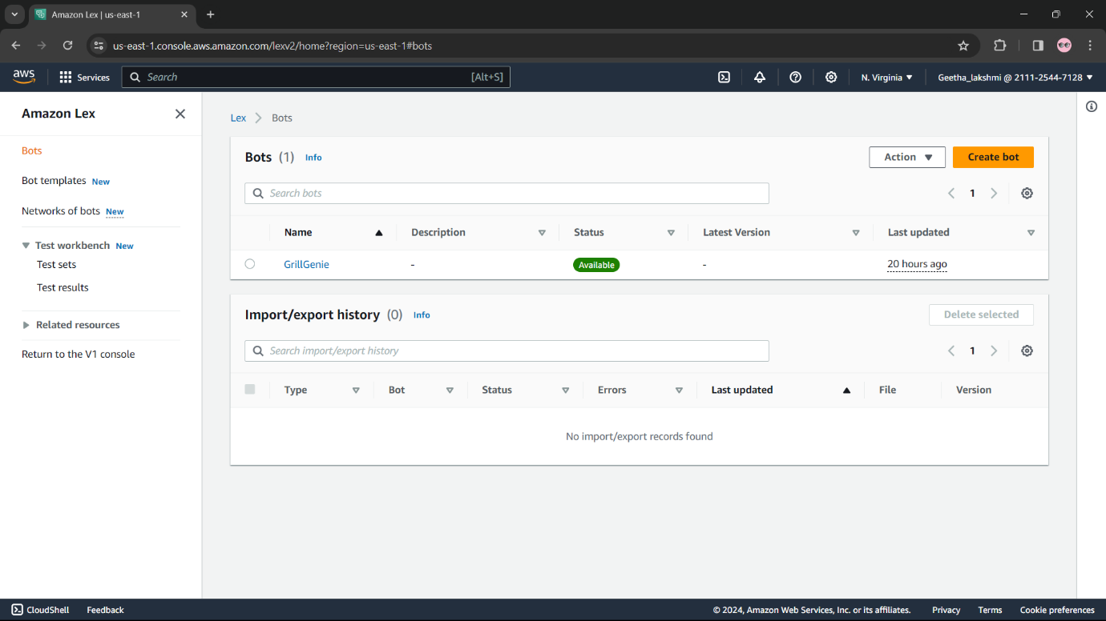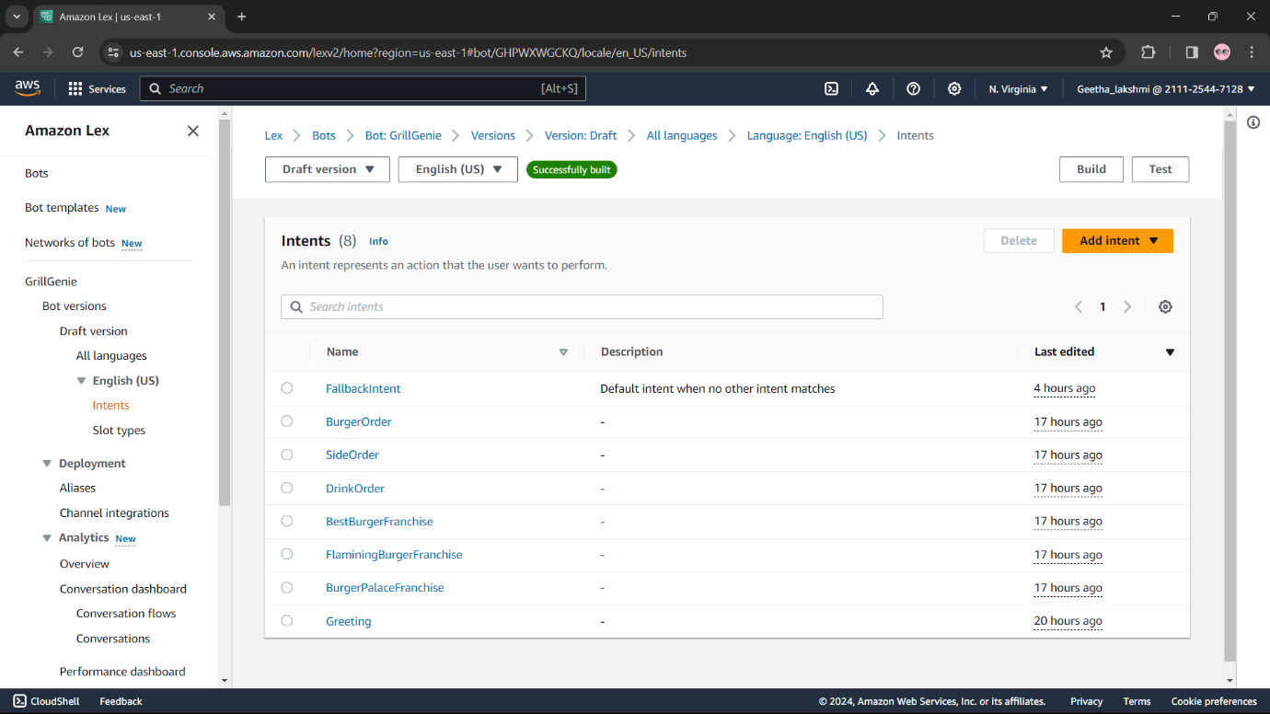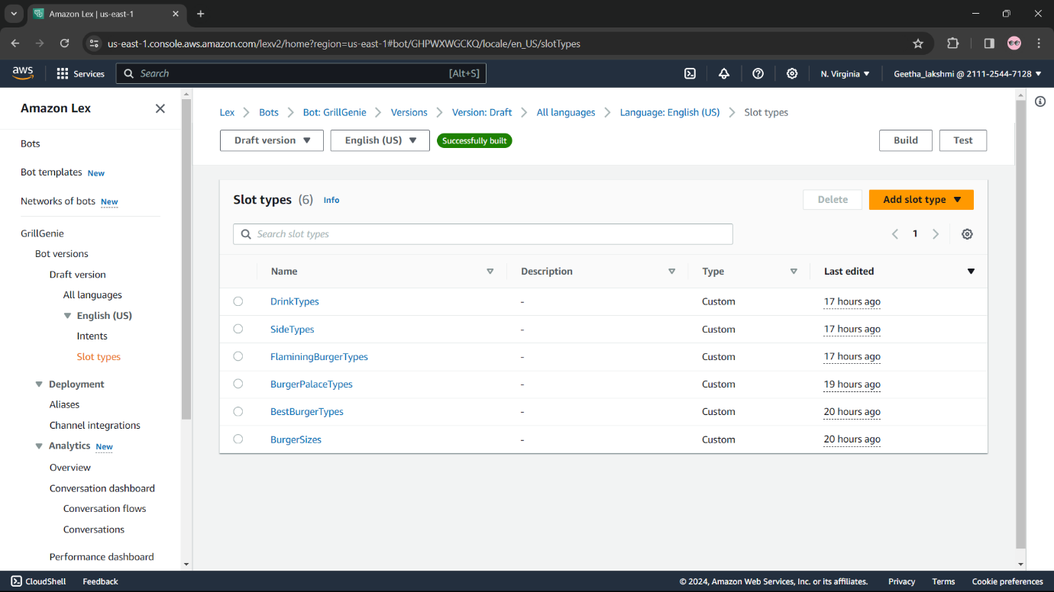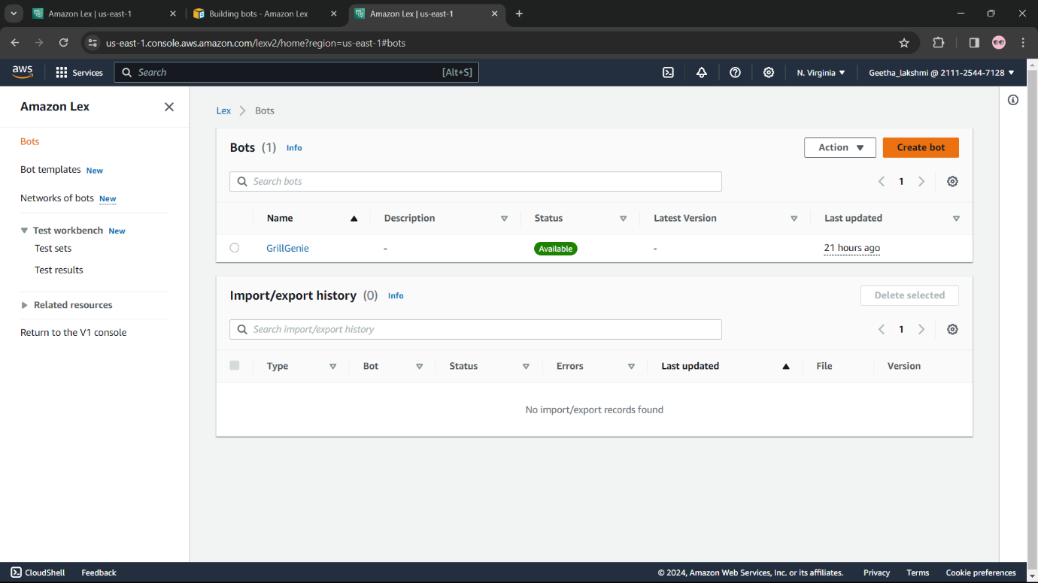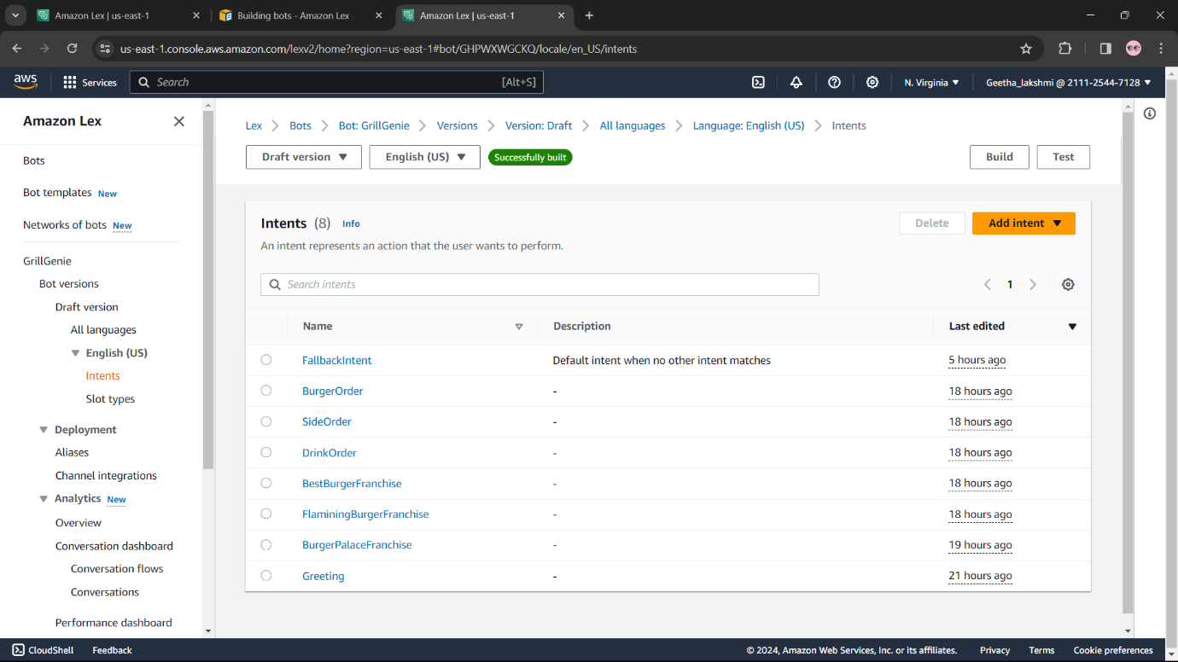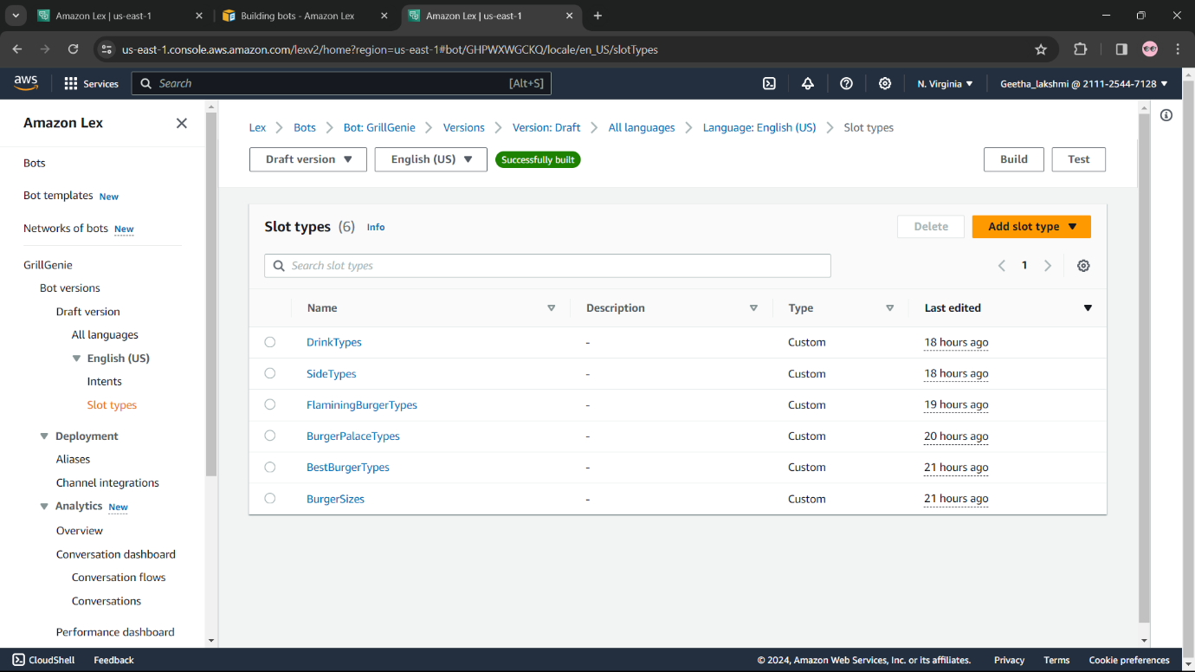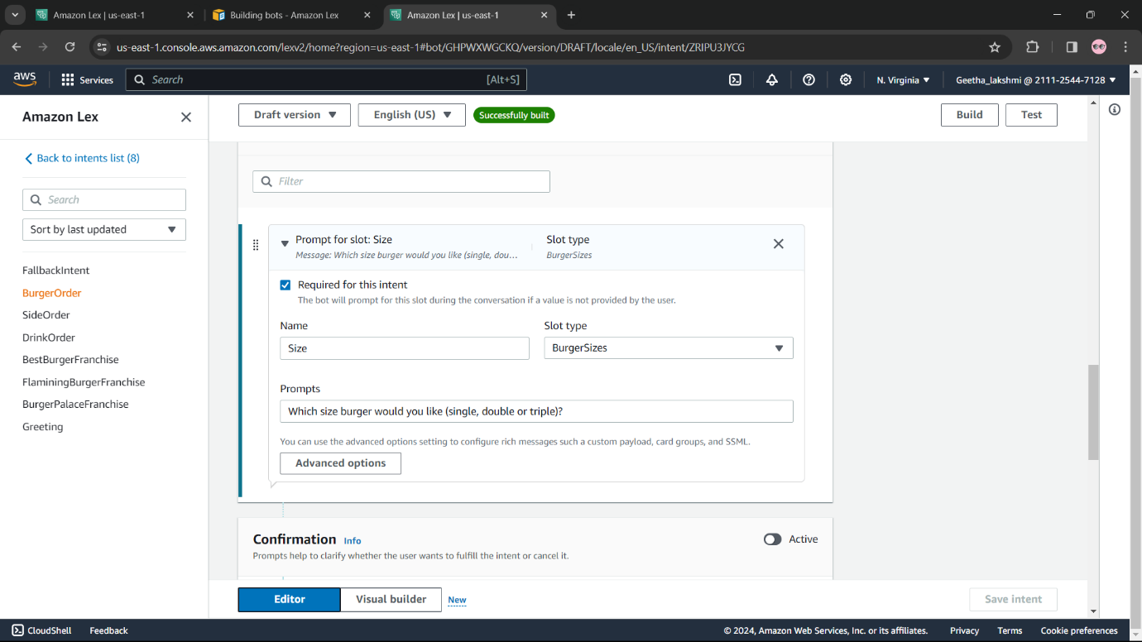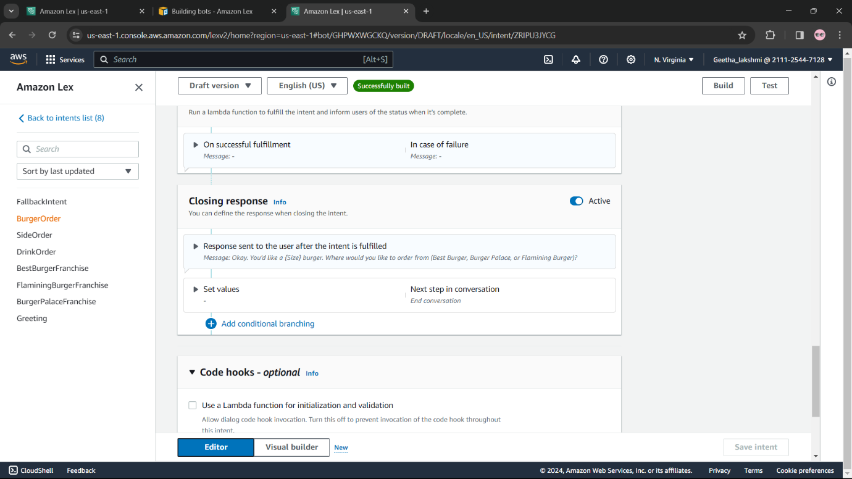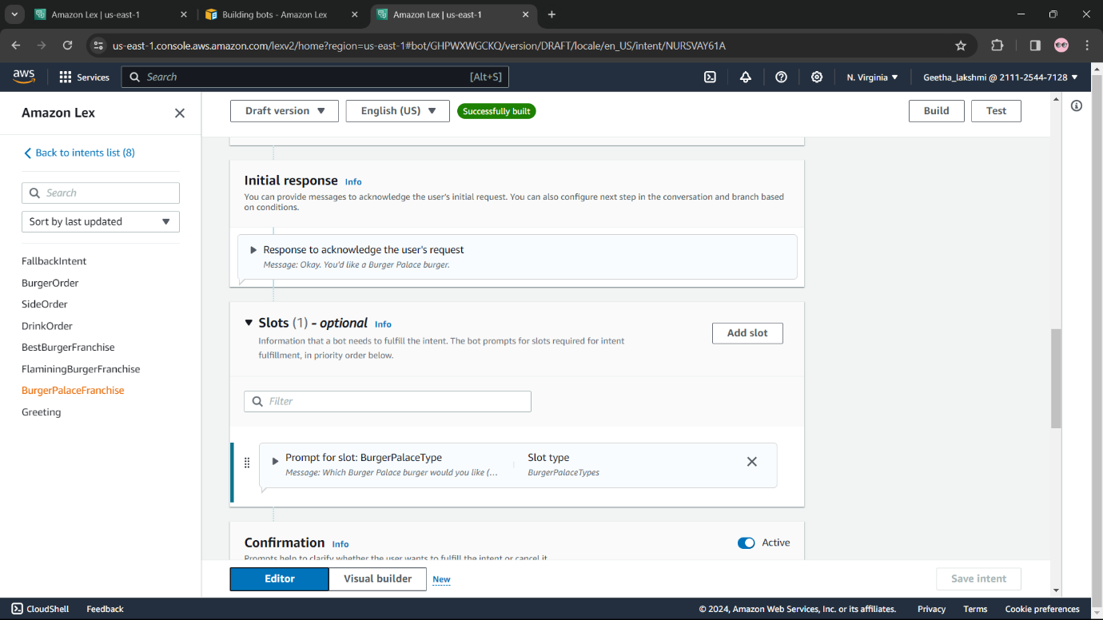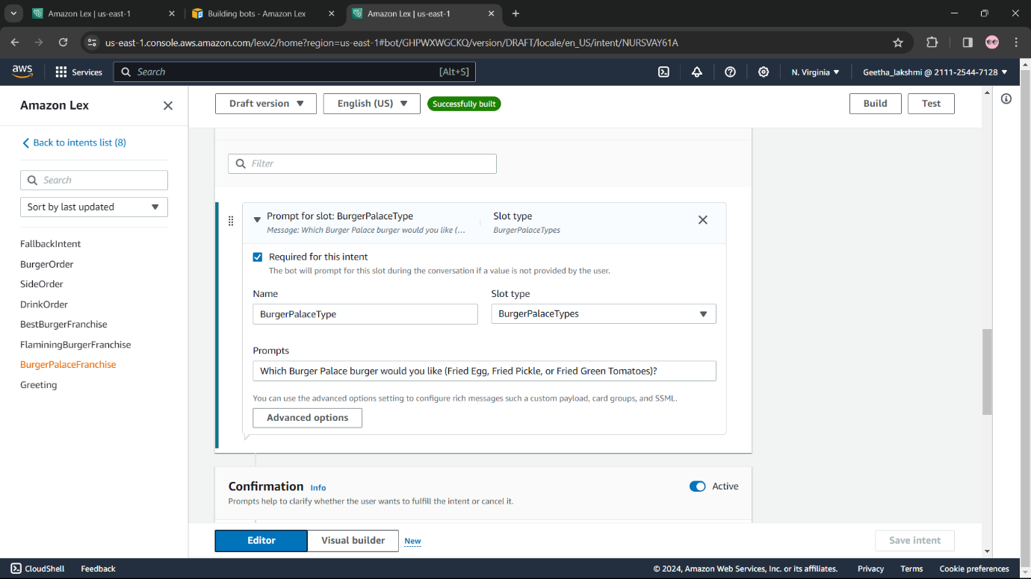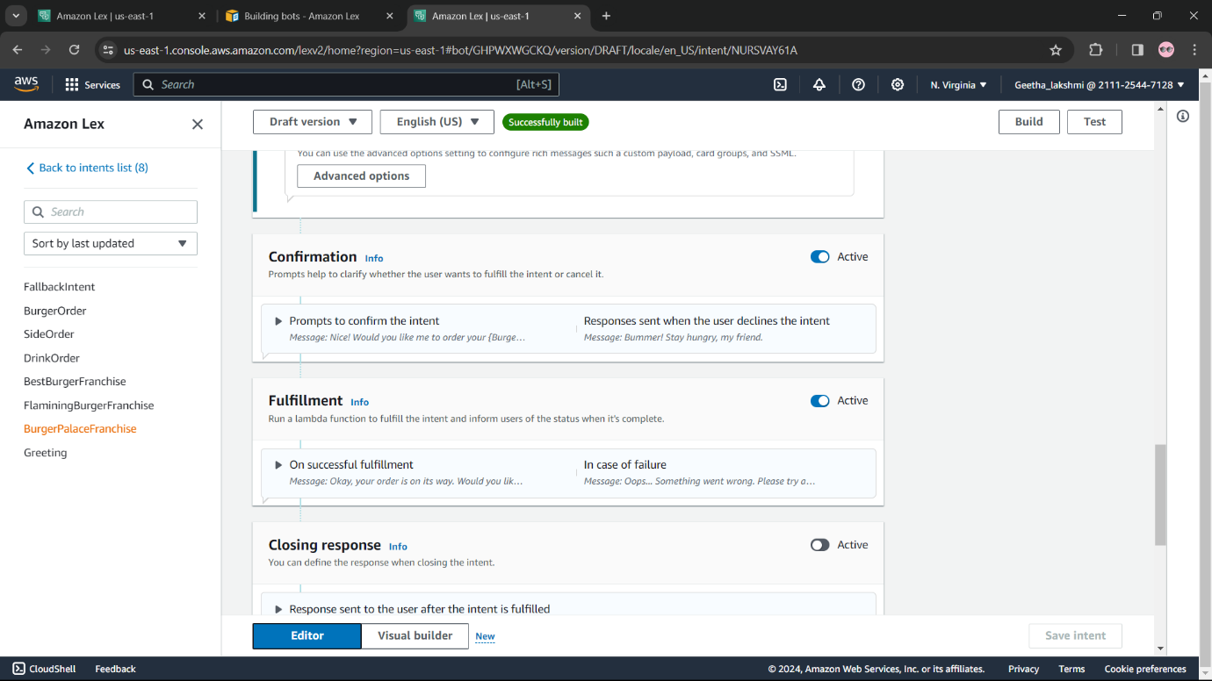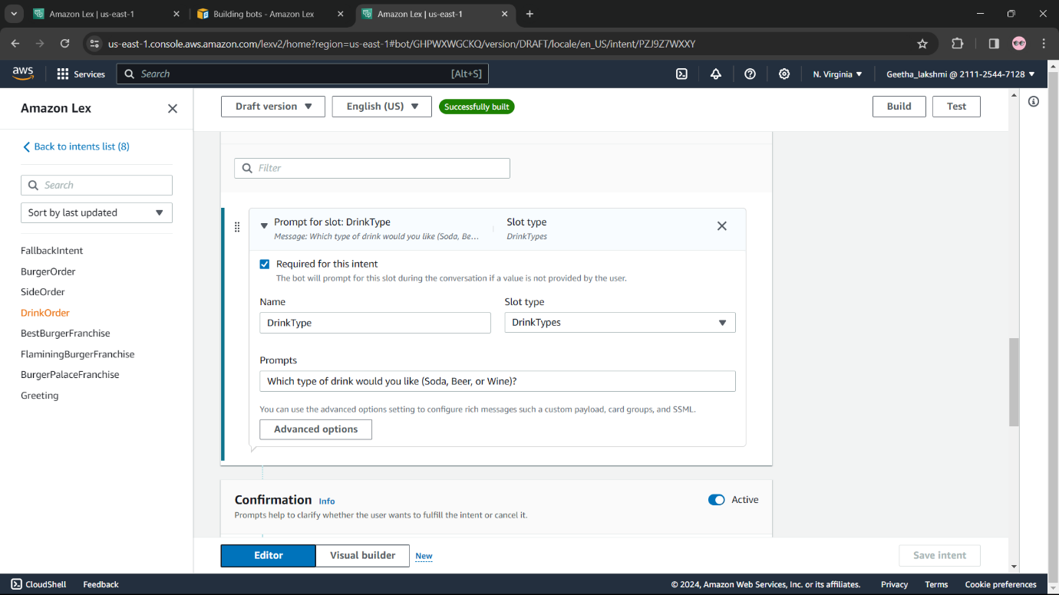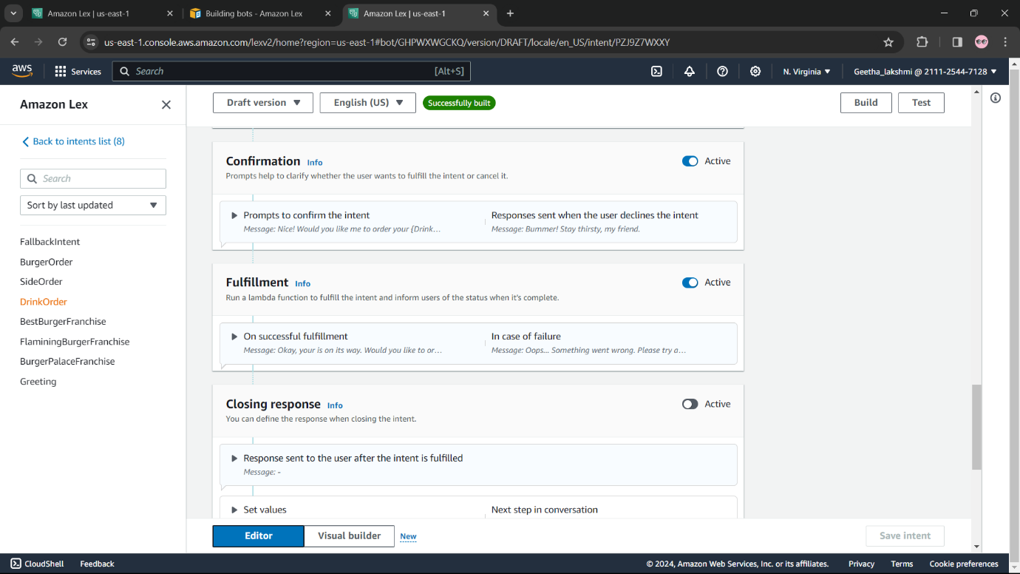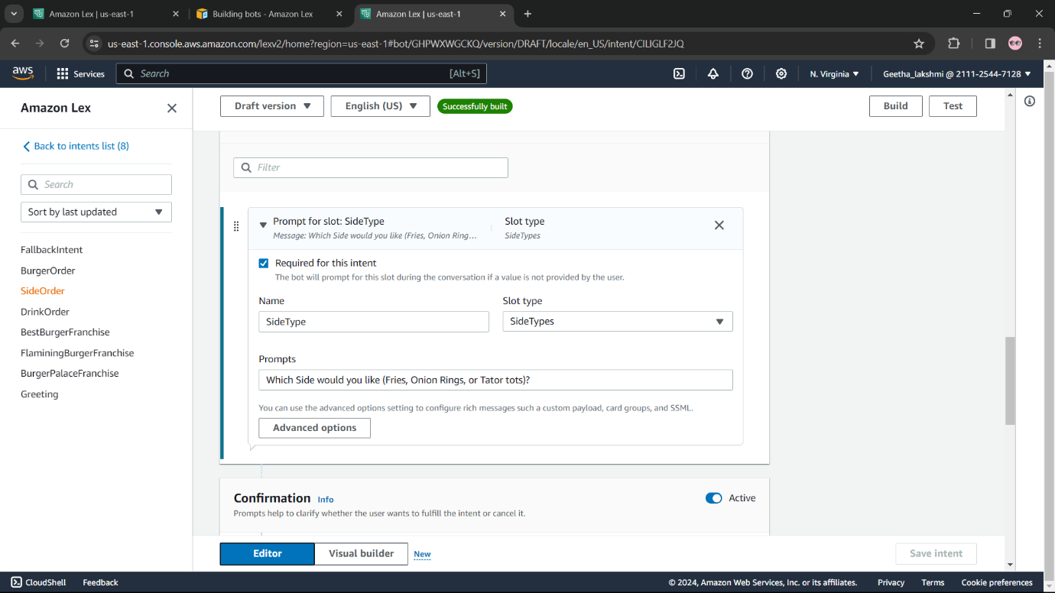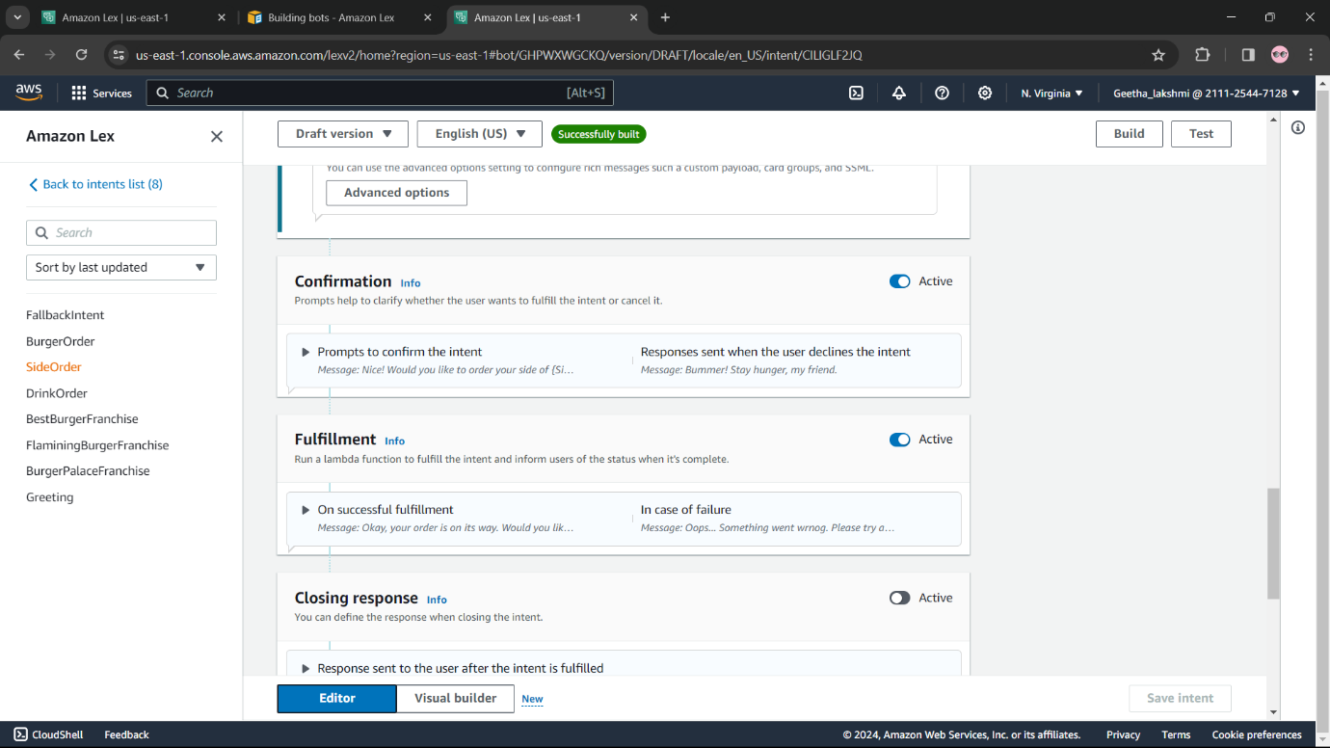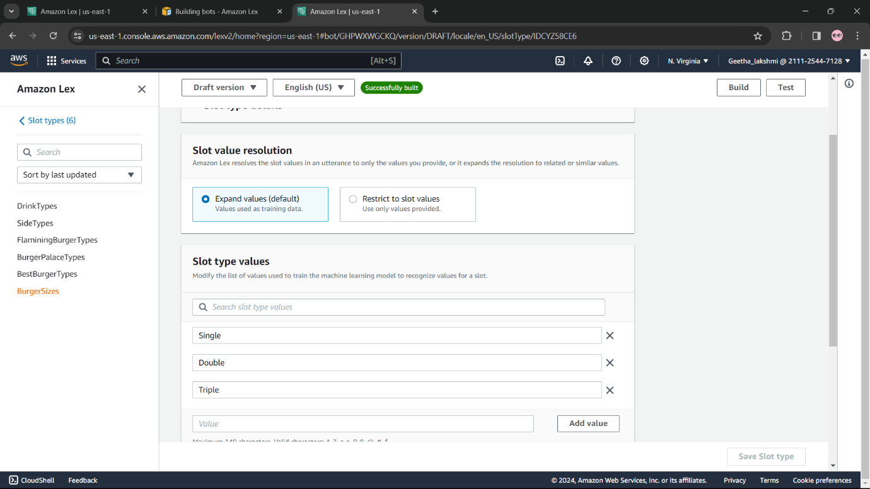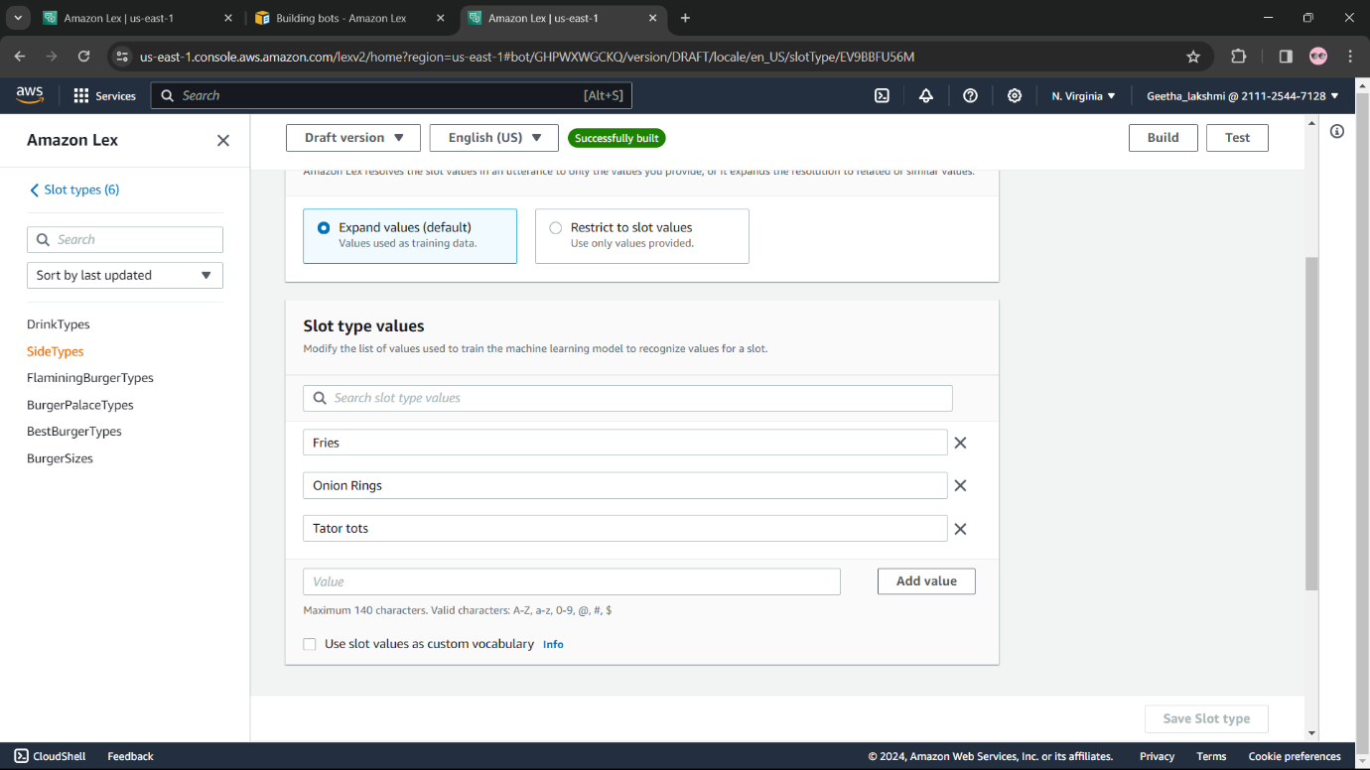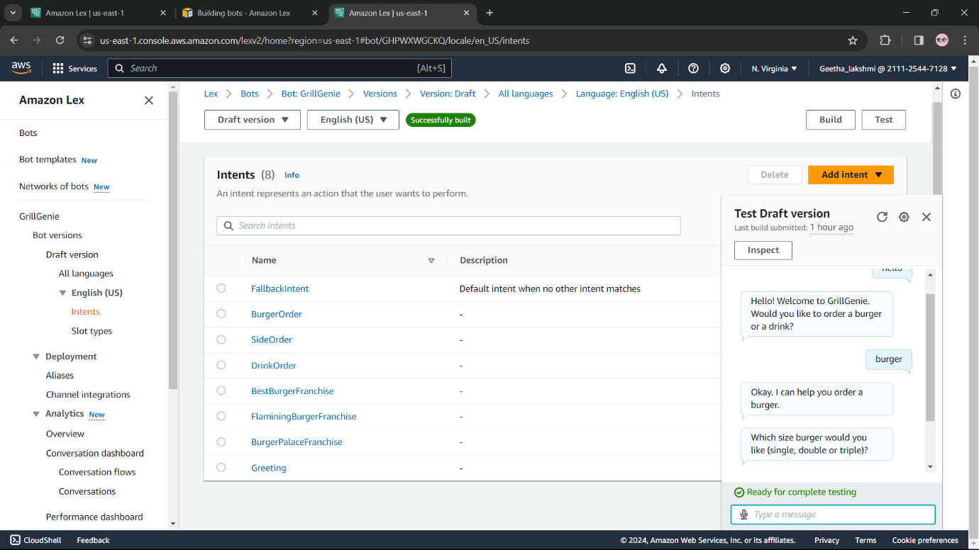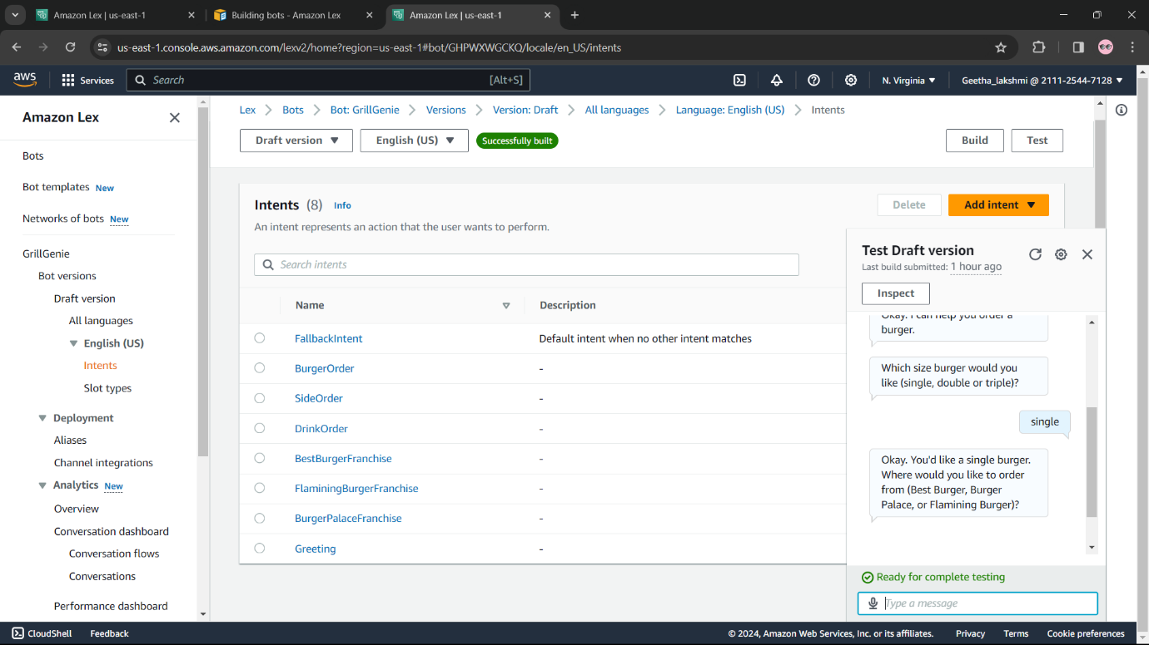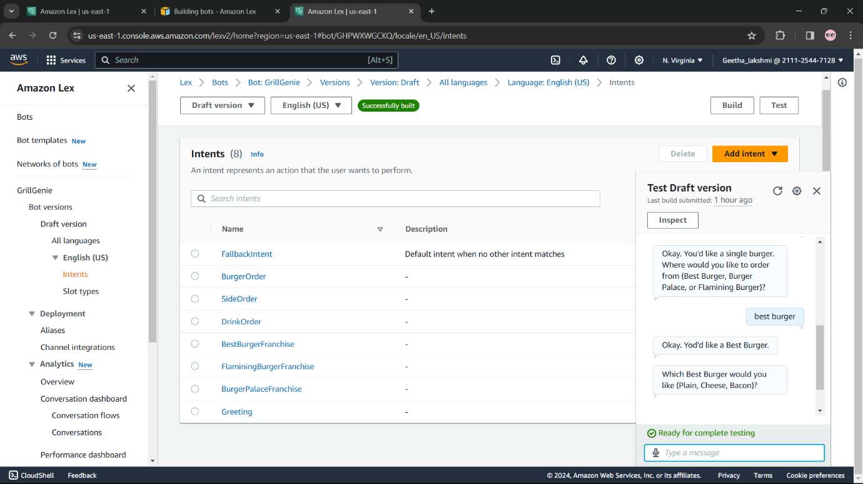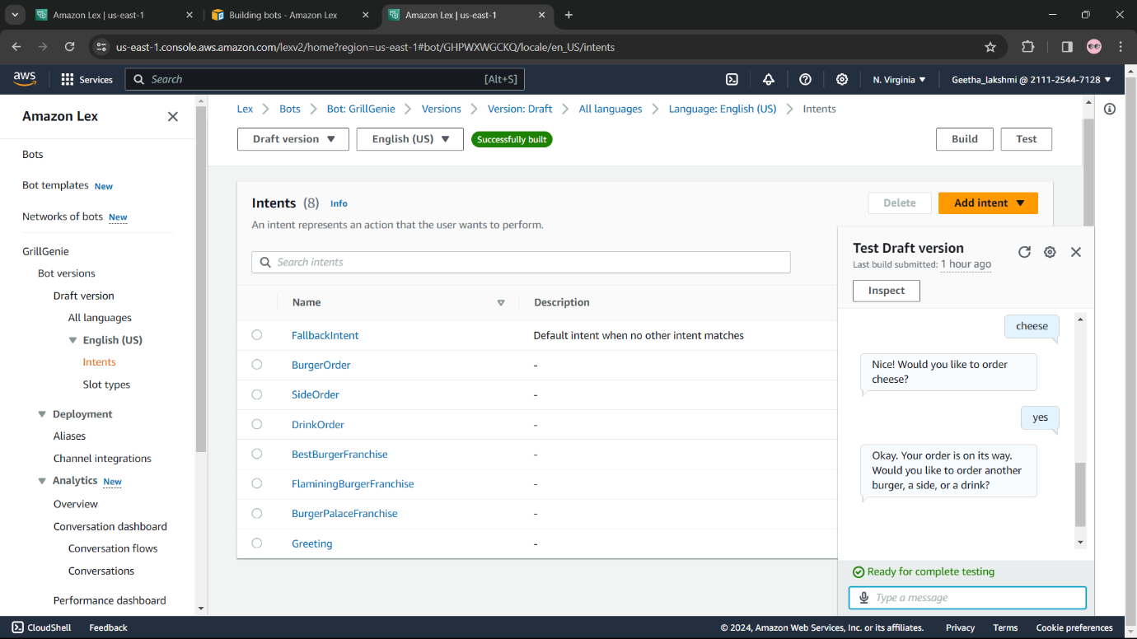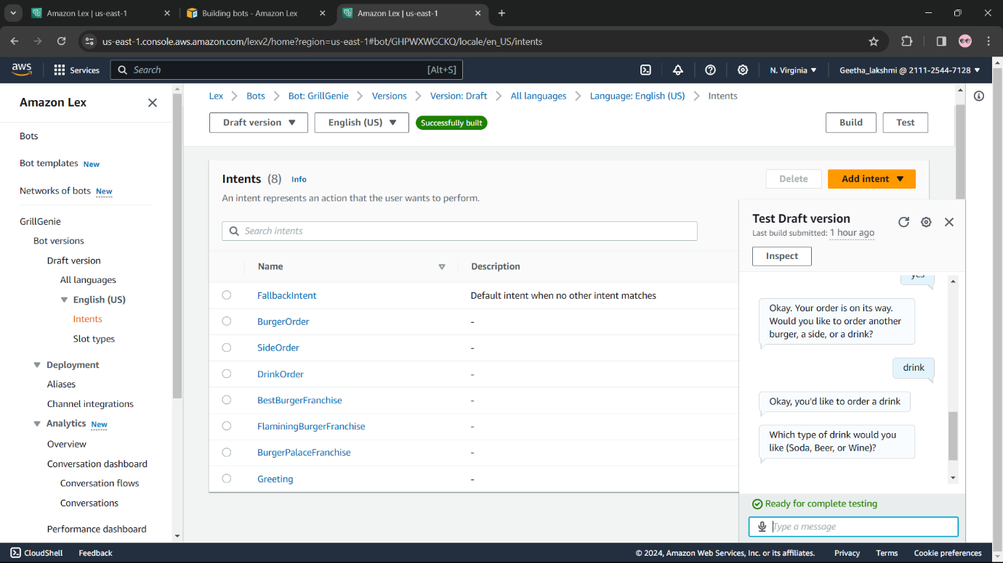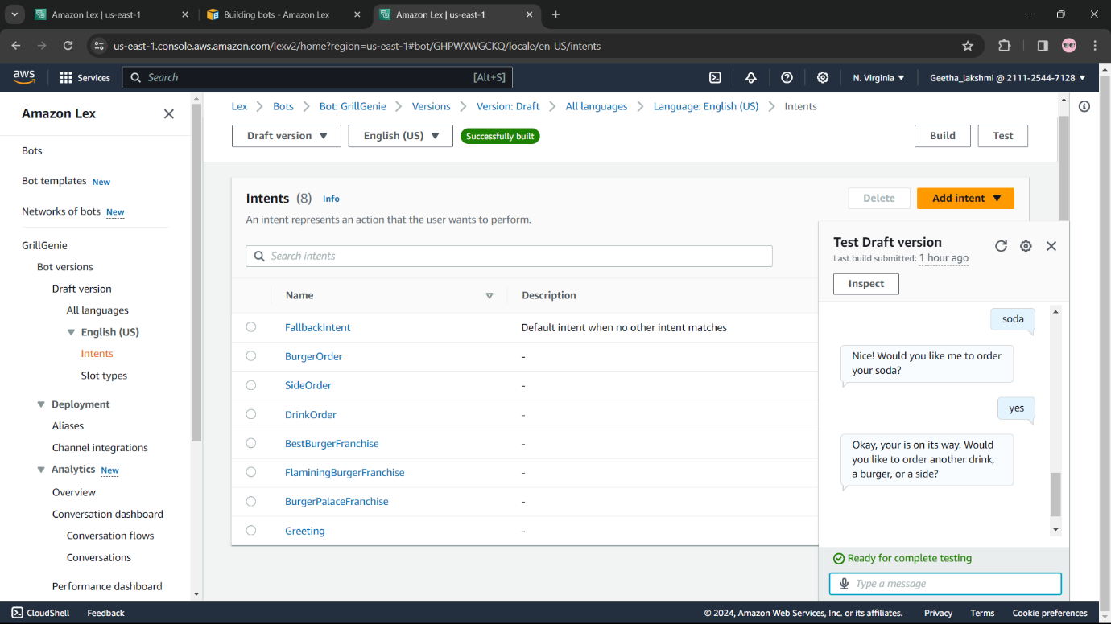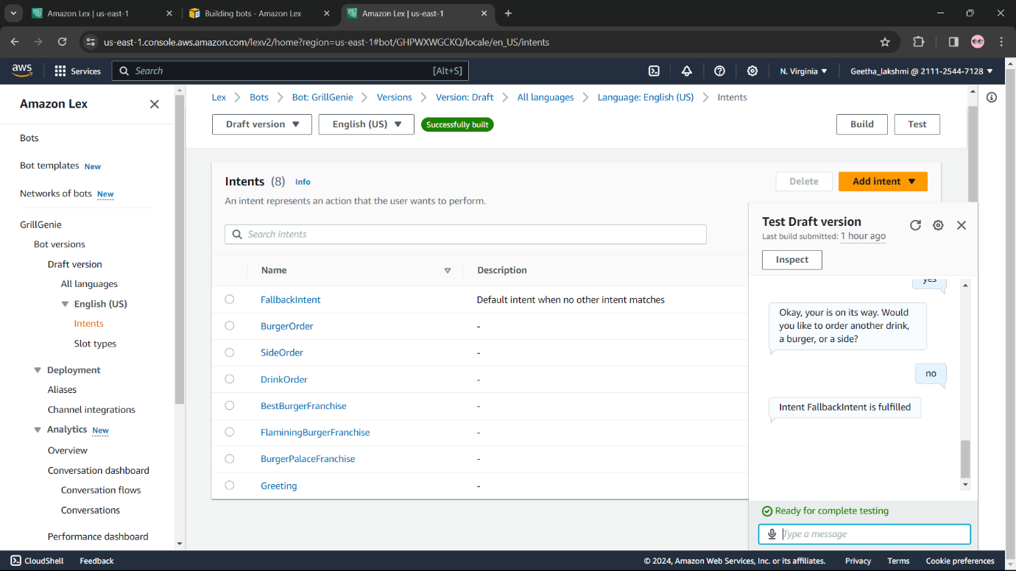

**Results:**

**The implementation of a chatbot the use of Amazon Lex can provide several advantages:**

**Scalable and Reliable:**

* Amazon Lex is a completely controlled provider that scales routinely and gives excessive availability, ensuring your conversational applications are continually to be had.

**Cost-Effective:**

* You most effective pay for the resources you use, making Lex a cost-powerful solution for constructing and deploying conversational programs.

**Secure and Compliant:**

* Lex is built at the steady and reliable AWS infrastructure, ensuring your data and applications are included and follow industry standards.

**Improved Customer Experience:**

* Chatbots can provide on the spot, personalised, and efficient provider, leading to higher customer satisfaction and loyalty.

**Increased Operational Efficiency:**

* Chatbots can automate repetitive responsibilities, reduce the workload on customer support agents, and enhance overall operational efficiency.

**24/7 Availability:**

* Chatbots can provide customer support and services around the clock, making sure that clients can get assist whenever they need it.

**Cost Savings:**

* By automating repetitive responsibilities, chatbots can assist companies reduce operational charges and enhance their bottom line.

**Conclusion:**

To sum up, creating a chatbot with Amazon Lex provides a danger to make use of AI to adapt to evolving client needs and boost enterprise boom. With the plan and execution technique outlined, Amazon Lex-driven chatbots can offer enticing person interactions and produce fee to numerous sectors.